Calendar Invitations For Your Event
We’re looking forward to seeing you. Here are some example invitations you can send to your team. Of course, customize them with your language.

Whenever possible:
- Include your exact event location and time.
- Attach your custom pre-work instructions (if StrengthsFinder codes are included in your event) so that they have the code to do their event prep.

Hyperlink Directly To Your Event Type To Get Relevant Text For Your Calendar Invitations
- Invitation Text for a Team Training, Open Session, or All-Employee type of event where you’re offering a strengths course for career development or a team building event. People use this one for conferences, company academies, or a general offering through a talent management group where employees can opt into the class from many different departments.
- Invitation Text for a Manager Event where leaders who have direct reports are there to get the tools they need to use strengths-based development on their team. Use this if it is explicitly a leadership event. If it’s a mixed audience, the first one is usually better.

- Additional Text for Language Support - special notes for those who have non-native English speakers who might want to take the StrengthsFinder assessment in another language.

Event Type: Training Open-Session/All Employee

Subject:
Discover Your Strengths and Put Them To Work

Description:
Have you ever wondered why some days feel productive and energizing, while others feel totally draining? Chances are, it’s the difference between the days you’re leaning on your strengths versus weaknesses.

Join our half-day course and find out why people who use their strengths every day feel 6x more engaged at work and 3x the wellbeing of their weakness-fixing peers.


https://www.canva.com/design/DAB1Je2bkdM/neLt2xYCBMjEr9OAtnzFmA/view?utm_content=DAB1Je2bkdM&utm_campaign=designshare&utm_medium=link&utm_source=viewer

DATE
TIME
LOCATION
+ ATTACH STRENGTHSFINDER PRE-WORK INSTRUCTIONS

Event Type: Manager Training

Subject:
Improve Performance & Engagement By Using Your Team Members’ Strengths

Description:
65% of employees reported receiving zero recognition for good work in the last year. Ouch. No wonder employees have a tough time nailing it. They get feedback that implies “not it, not it, not it” throughout the year, yet they are often oblivious to the factors that can make them a star performer.

They’re often blind to their own strengths. And managers tend to neglect telling them when they see their talents in action. Those two factors leave most workplaces full of untapped potential.

Join this half-day course and find out why teams that focus on strengths every day have 12.5% greater productivity (source for stats: Gallup). Most of all, get the tools and tactics you need to lead your own team from a strengths-based approach.

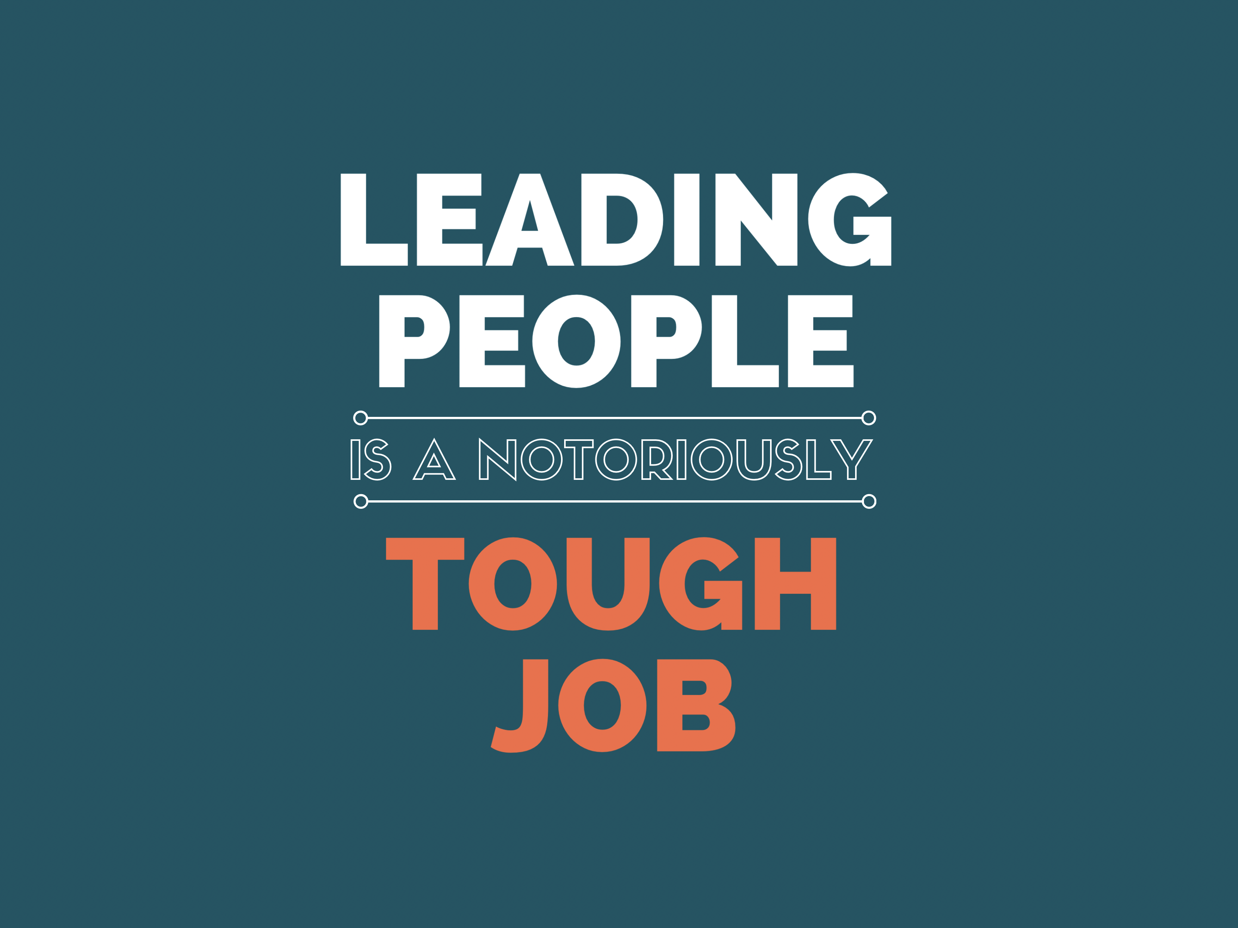
https://www.canva.com/design/DAD6wYRrBSE/sI-zLFPHKYmo_n3wiJpTTw/view?utm_content=DAD6wYRrBSE&utm_campaign=designshare&utm_medium=link&utm_source=homepage_design_menu

DATE
TIME
LOCATION
+ ATTACH STRENGTHSFINDER PRE-WORK INSTRUCTIONS

Additional Text: Language Support

Description To Add When You Have Non-Native English Speakers:

*Please note that when you first log in to complete the survey, you are given the choice of which language to use. Please select your native language to get more accurate results. Although the course delivery will be in English, you can still get your report and take the assessment in your native language.

